February - April 2025

Rawad - w19885025

Bhavjot - w1972756

Mourad - w1960946

Kelvin - w18984891

Mohammad - w1996549

Data Science Project Lifecycle - Group Coursework

Enhancement Report

Understanding Communities In Need

**Introduction to the Project** (Majority: *Rawad,* Support: *Bhavjot*)

The global sneaker industry is a major contributor to environmental degradation, Responsible for 1.4% of global greenhouse gas emissions and almost as much as the aviation sector's 2.5%. Every year, 20 billion pairs of shoes are produced, yet 300 million end up in landfills, contributing significantly to waste and pollution. Coupled with this is the social issue of Fuller accessibility, particularly for individuals facing poverty and homelessness.

Resole, founded in 2018 by Musa Nsubuga, addresses these dual challenges through its innovative “Reduce, Reuse, Recycle” model. Operating from its Brixton Village Hub, Resole has redistributed over 25,000 pairs of trainers worth £2 million to vulnerable groups, including the homeless, refugees, and low-income families. The organisation partners with charities, shelters, and soup kitchens, bridging environmental sustainability and social welfare.

**Problem Domain**

Resole faces several operational challenges including:

* Assessing the efficiency of its redistribution process.
* Determining which regions have the highest demand for footwear.
* Enhancing inventory tracking and management systems.
* Measuring the social and environmental impact of its initiatives.

These challenges highlight the need for systematic analysis and data-driven solutions to enhance Resole’s operations and maximise its social impact.

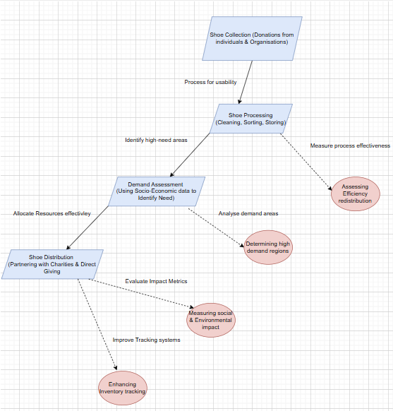

The flowchart above outlines the current processes, problems, and main objectives that Resole undertakes. The fundamental aim is to distribute shoes effectively and to those who need them. This process encounters problems mentioned previously. Our job is to gain insights from data to explain and coordinate how to counter these issues, thus making the process easier and more efficient.

**Problem Structuring with Soft Systems Methodology (SSM).**

To systematically address Resole’s Challenges, we apply Soft Systems Methodology. This helps structure the problem by identifying the key stakeholders, their roles, and problems that affect their redistribution efficiency.

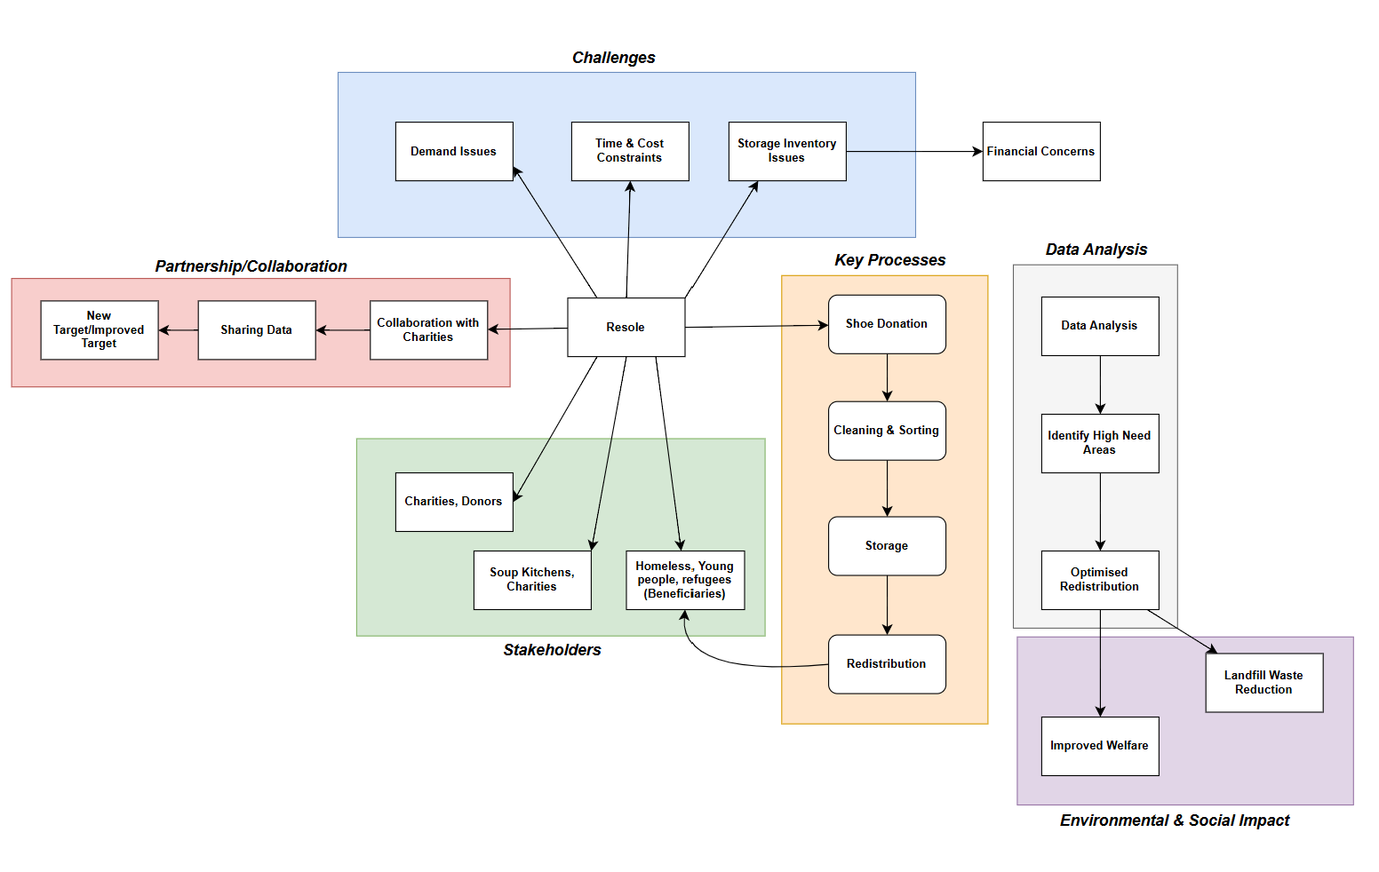

The flowchart shown above illustrates Resole’s workflow and challenges. IT highlights key stakeholders, processes, and areas that needs improvements.

1. **Root Definition**

* Efficient shoe redistribution to high-need groups.
* Resole, charities, food banks, shoe donors.
* Collection, cleaning, storage, and redistribution.

1. **CATWOE Analysis**

* **Customer –** Homeless Individuals, low-income families, refugees.
* **Actors –** Resole team, volunteers, charities, donation partners.
* **Transformation Process –** Convert donated shoes into usable footwear for the vulnerable.
* **Worldview –** Sustainable redistribution reduces environmental waste and social inequality.
* **Owners –** Resole
* **Environmental Constrains –** Storage space, manpower, limited funding.

**Objectives**

This project seeks to:

* Analyse socio-economic, demographic, and resource accessibility data to identify high-need areas across the UK.
* Model deprivation levels to predict future demand and optimise distribution strategies.
* Develop a dashboard to visualise key findings, enabling data-driven decision-making.

By addressing these objectives, the project aims to provide actionable insights that strengthen Resole’s capacity to support communities, reduce environmental waste, and promote sustainability within the footwear industry.

***Project Planning and Risk Assessment*** (Majority: *Bhavjot*, Support: *Kel, Mourad, Mo*)

***Project Deliverables***

The key deliverables for this project include:

1. **Data Analysis Report**

* A structured report containing insights on shoe demand trends, storage challenges, and priority groups.
* Visualisations such as Graphs/Charts/Tables to illustrate key findings.

1. **Data Cleaning and Processing Framework**

* A documented Approach for handling missing/incomplete data.
* Steps for ensuring data quality before analysis.

1. **Recommendations for Resole**

* Practical suggestions to improve efficiency in shoe distribution and storage.
* Potential collaborations with organisations to enhance their operations.

1. **Final Presentation**

* A summary of findings and recommendations presented to stakeholders/lecturer.

***Team Roles & Responsibilities***

For Team Roles & Responsibilities, our team followed a highly collaborative approach, all members actively contributed across the project’s phases , including **planning, research, data analysis, modeling, visualisation, and report writing**.

* ***Project Coordinator*** – (*Bhavjot*) Ensured effective communication, and timeline management to keep the project on track.
* ***Research Contributor*** (*Rawad*)- Conducted background research, gathered insights, and structured the problem domain for a data-driven approach.
* ***Data Analyst*** (*Mourad*)- Assisted in data collection, cleaning, and analysis, as well as ensuring the quality and accuracy of the data for further processing.
* ***Modelling & Insights Developer*** (*Mohammad*)- Contributed to modelling techniques and provided insights based on the data findings.
* ***Report & Documentation Contributor*** (*Kelvin*)- Participated in writing and structuring the report, ensuring clarity, and alignment with project objectives.

**Key Responsibilities:**

* Communication & Coordination
* Completing assigned work while supporting others.
* Deadline Management - Meeting project milestones on time
* Problem–Solving - Identifying challenges and refining solutions
* Feedbacks & Reviews

***Work Breakdown Structure (WBS)***

|  |  |  |  |  |
| --- | --- | --- | --- | --- |
| **Deliverable** | **Sub-Task** | **Work Package** | **ID** | **Item Name** |
| X |  |  | 1 | Background Research |
|  | X |  | 1.1 | Identify key socio-economic deprivation factors |
|  |  | X | 1.1.1 | Research government deprivation indices |
|  |  | X | 1.1.2 | Identify challenges faced by Resole |
|  |  | X | 1.1.3 | Understand existing redistribution workflows |
| X |  |  | 2 | Data Collection & Preparation |
|  | X |  | 2.1 | Identify and gather relevant datasets |
|  |  | X | 2.1.1 | Explore publicly available datasets |
|  |  | X | 2.1.2 | Integrate external data sources |
|  |  | X | 2.1.3 | Conduct interviews with Resole representatives |
|  | X |  | 2.2 | Clean and preprocess the collected data |
|  |  | X | 2.2.1 | Handle missing values |
|  |  | X | 2.2.2 | Standardize data formats |
|  |  | X | 2.2.3 | Merge and integrate datasets |
|  |  | X | 2.2.4 | Encode categorical variables |
| X |  |  | 3 | Exploratory Data Analysis (EDA) |
|  | X |  | 3.1 | Analyze deprivation trends |
|  |  | X | 3.1.1 | Generate descriptive statistics |
|  |  | X | 3.1.2 | Visualize geographic distribution of need |
|  |  | X | 3.1.3 | Identify correlations between deprivation indicators |
| X |  |  | 4 | Trends & Predictive Modelling |
|  | X |  | 4.1 | Develop forecasting models |
|  |  | X | 4.1.1 | Select appropriate statistical techniques |
|  |  | X | 4.1.2 | Train and validate predictive models |
|  |  | X | 4.1.3 | Evaluate model performance |
| X |  |  | 5 | Dashboard Development |
|  | X |  | 5.1 | Build interactive visualizations |
|  |  | X | 5.1.1 | Develop deprivation heatmaps |
|  |  | X | 5.1.2 | Create trend analysis charts |
|  |  | X | 5.1.3 | Implement geographic ranking dashboards |
| X |  |  | 6 | Business Report & Presentation |
|  | X |  | 6.1 | Compile findings and recommendations |
|  |  | X | 6.1.1 | Draft a report detailing insights |
|  |  | X | 6.1.2 | Highlight assumptions, risks, and limitations |
|  |  | X | 6.1.3 | Provide recommendations for Resole |
|  | X |  | 6.2 | Create and deliver final presentation |
|  |  | X | 6.2.1 | Prepare a 10-minute executive summary |
|  |  | X | 6.2.2 | Develop engaging and concise slides |
|  |  | X | 6.2.3 | Present findings to stakeholders |

**Time plan**

|  |  |  |  |
| --- | --- | --- | --- |
| ***ID*** | ***Item Name*** | ***Duration*** | ***Depends on*** |
| 1 | Background Research | 1 week | - |
| 1.1 | Identify key socio-economic deprivation factors | 2 days | - |
| 1.1.1 | Research government deprivation indices | 2 days | 1.1 |
| 1.1.2 | Identify challenges faced by Resole | 2 days | 1.1 |
| 1.1.3 | Understand existing redistribution workflows | 2 days | 1.1 |
| 2 | Data Collection & Preparation | 2 weeks | 1 |
| 2.1 | Identify and gather relevant datasets | 3 days | 1 |
| 2.1.1 | Explore publicly available datasets | 2 days | 2.1 |
| 2.1.2 | Integrate external data sources | 3 days | 2.1.1 |
| 2.1.3 | Conduct interviews with Resole representatives | 3 days | 2.1 |
| 2.2 | Clean and preprocess the collected data | 1 week | 2.1 |
| 2.2.1 | Handle missing values | 2 days | 2.2 |
| 2.2.2 | Standardize data formats | 2 days | 2.2 |
| 2.2.3 | Merge and integrate datasets | 3 days | 2.2.2 |
| 2.2.4 | Encode categorical variables | 2 days | 2.2.3 |
| 3 | Exploratory Data Analysis (EDA) | 1.5 weeks | 2 |
| 3.1 | Analyze deprivation trends | 3 days | 2 |
| 3.1.1 | Generate descriptive statistics | 2 days | 3.1 |
| 3.1.2 | Visualize geographic distribution of need | 3 days | 3.1 |
| 3.1.3 | Identify correlations between deprivation indicators | 3 days | 3.1 |
| 4 | Trends & Predictive Modelling | 2.5 weeks | 3 |
| 4.1 | Develop forecasting models | 1 week | 3 |
| 4.1.1 | Select appropriate statistical techniques | 3 days | 4.1 |
| 4.1.2 | Train and validate predictive models | 5 days | 4.1.1 |
| 4.1.3 | Evaluate model performance | 4 days | 4.1.2 |
| 5 | Dashboard Development | 2 weeks | 4 |
| 5.1 | Build interactive visualizations | 4 days | 4 |
| 5.1.1 | Develop deprivation heatmaps | 3 days | 5.1 |
| 5.1.2 | Create trend analysis charts | 3 days | 5.1 |
| 5.1.3 | Implement geographic ranking dashboards | 3 days | 5.1 |
| 6 | Business Report & Presentation | 2 weeks | 5 |
| 6.1 | Compile findings and recommendations | 3 days | 5 |
| 6.1.1 | Draft a report detailing insights | 3 days | 6.1 |
| 6.1.2 | Highlight assumptions, risks, and limitations | 3 days | 6.1.1 |
| 6.1.3 | Provide recommendations for Resole | 2 days | 6.1.1 |
| 6.2 | Create and deliver final presentation | 1 week | 6.1 |
| 6.2.1 | Prepare a 10-minute executive summary | 3 days | 6.2 |
| 6.2.2 | Develop engaging and concise slides | 3 days | 6.2 |
| 6.2.3 | Present findings to stakeholders | 1 day | 6.2.2 |

**Gantt Chart**

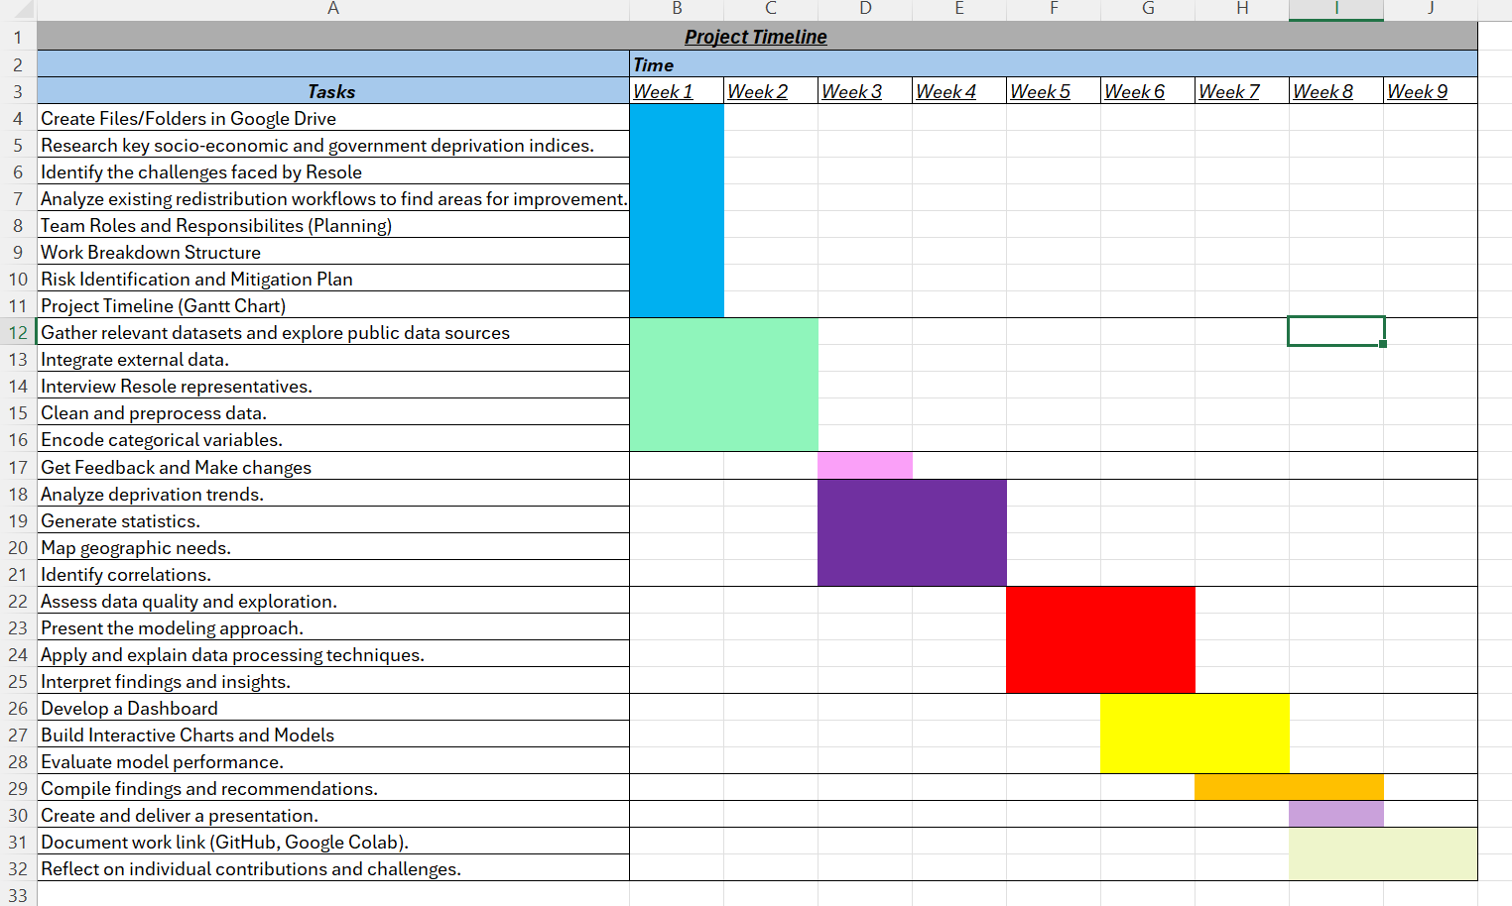

This Gantt chart represents a project aimed at Understanding communities in need powered by Resole. It outlines the key tasks such as Researching key socio-economic and government deprivation indices, gathering relevant data internally and externally, Generating statistics, which are scheduled over a period from 27th February 2025 to 3rd April 2025. The chart clearly shows the Duration of each task and highlights dependencies that are needed to be completed before the next task can begin.

***Risk & Mitigation Plan***

|  |  |  |  |
| --- | --- | --- | --- |
| Risk | Likelihood | Impact | Mitigation Strategy |
| Incomplete Data | High | High - Incorrect Insights leading to poor decision making. | Requesting additional datasets from Resole, use external sources, use assumptions if necessary. |
| Time Constraints | High | High - Project delays and even failing the project | Prioritise critical tasks, set milestones |
| Technical Challenges | Medium | High - Delays in project completion | Use simple models and review with lecturers if needed |
| Lack of Group Engagement | Medium | High - Reduced productivity and uneven workload distribution | Schedule regular check ups, set clear individual responsibilities. |
| Conflicts in Decisions | Low | Medium - Disagreements can slow the progress | Establish clear decisions, encourage discussions. |
| Software Limitations | Medium | High – Issues with visualising and analysing data | Use friendly tools such as Power BI, Tableau. |
| Data Processing Errors | High | High – Incorrect insights may give misleading decisions | Ask for confirmation when removing certain rows/columns, keep backup of original data. |
| Dashboard Usability | Medium | Medium – Harder to use and unable to interpret the data | Gather Resole’s feedback on it and easily explain it to them. |

***Interview Insights: Understanding Resole’s Needs***

To gain a deeper understanding of Resole’s operations and challenges, we conducted an interview with a Resole representative, who provided valuable insights into the difficulties of footwear redistribution, storage limitations, and the need for a more data-driven approach to optimize distribution.

One of the challenges I faced was organising the interview responses in a clear and structured way without losing any important details. Some answers were quite broad, so it took some effort to interpret and condense the key points while keeping everything accurate. I also had to ensure there wasn’t too much repetition and that the information flowed logically.

|  |  |
| --- | --- |
| **Questions asked** | **Answers** |
| What specific key deliverables would be most valuable to Resole's objectives? | **Cleaning**, it needs to be more effective, **financially** and in 5 to 10 years people should donate a lot more shoes. |
| Are there any seasonal or temporal trends in demand for footwear (e.g., higher demand during winter months or back-to-school periods) that we should account for in our analysis? | * In the summertime we get more parents. * People like to save them as memories * We send more shoes to childrens. * Festive seasons, mostly after christmas * From december to february |
| Does Resole collaborate with any other organisations or government bodies that could provide additional data or insights for this analysis? | They are sponsored by Crep Protect so they have free cleaning supplies |
| How does Resole currently identify and prioritise individuals in need of footwear, and are there specific groups (e.g., children, homeless individuals, low-income families) that receive priority in distribution? | * The key service users for Resole are primarily homeless individuals, as they are the most common group in need of shoes. * The second priority is young people, helping keep them away from crime by providing shoes that promote education and personal well-being. * Refugees are the third priority group, as they often lack access to basic necessities. |
| Have you encountered any significant challenges when it comes to predicting shoe demand | Challenges are in storage and manpower (team capacity) and software issues.  Sending email and phone calls, which is tedious, (it's a long process, it is tiring)  The location also must be feasible for them too. |
| How should we handle missing or incomplete data? | By keeping the critical information |
| Are there specific socio-economic indicators we should focus on? | * Homeless * Young people * Refugees |
| What are the most important insights we need to provide in our analysis? | Anything that helps Resole to expand and provide shoes in priority order of:   * Homeless * young people * Refugees |
| On the easy read word document, why is there an asylum seeker category for employment if ‘asylum seekers’ also are included in the unable to work category? | How it was input by the user in the survey, |
| Will we be able to receive data from the locations that act as the distributors such as soup kitchens, charities? | Forms are given to them and they fill it out. Resole may be able to provide this data from their partnerships |

**Additional Insights from Resole Interview:**

***Key Service Users and Prioritization***

* People have jobs but are still unable to buy shoes, which is a common issue addressed by Resole.

***Operational Challenges***

* Storage and Cleaning:
  + About 30% of shoes are cleaned every month, and 70% is redistributed.
  + Cleaning process: Shoes are cleaned using a brush, steam cleaner, and a solution. The process varies depending on the condition of the shoes.
  + Shoes are checked for condition, and if they are not usable, they are recycled through incineration.
  + Resole has two hubs for managing operations.
  + Bigger brands charge premium prices for shoes, while Resole works to take shoes away from landfills.
  + The cleaning process can take 3-4 hours depending on the shoe condition. Resole also uses a solution for cleaning, with a minimum price of £20 for the cleaning service.
* Inventory and Distribution:
  + Shoes are stored manually in a storage space.
  + Resole works with food banks and soup kitchens to help identify and prioritize those in need of shoes. They use forms filled out by these partners to gather information on the types and sizes of shoes needed.
  + The organization also sends out appeals for children’s shoes to increase supply.
  + Shoes are distributed based on size, with a focus on size 7 to 11 for adults.
  + Resole’s ideal outcome is a more financially, environmentally, and time-efficient system that involves working with other communities to make a difference and increase awareness.
  + Resole has a circular system for intake and outtake, but they don’t have enough shoes to meet the demand.

***Cleaning Process and Manual Effort***

* Cleaning and Storage:
  + The cleaning process involves brushes, steam cleaning, and applying a solution based on shoe condition.
  + Shoes that are not in usable condition are recycled by incinerating them.
  + Manual labor is involved in both cleaning and storage processes.
  + It can take 3-4 hours (sometimes 2-3 hours) to clean a batch of shoes.

***Cost and Financial Considerations***

* Resole’s goal is to distribute shoes cost-effectively to those in need.
* Packaging for customers paying for cleaning services is important, as it adds a sense of value to the product.
* The minimum cost for cleaning is set at £20.
* Resole has a limited number of people working on cleaning, with a maximum of 4 people involved in the process.

***Outreach and Partnerships***

* Resole works with a range of community organizations, including food banks and soup kitchens, to identify and prioritize individuals in need of shoes.
* They gather information about shoe sizes through forms filled out by these partners.
* Resole regularly works with partners in Manchester, Birmingham, and other cities, though they only have data for London.
* Resole collaborates with sneaker events and receives shoes when people move to new places, which helps increase the quantity and quality of the shoes available for redistribution.
* Shoe donations also come from people who attend sneaker events.
* Resole considers those on universal credit for shoe donations, ensuring that even individuals who are receiving social benefits are not excluded from support.

***Seasonal Trends and Demand***

* There is also a spike in demand during festive seasons.
* During the summer months, Resole receives more requests, particularly from parents for children’s shoes.

***Data and Partner Collaboration***

* Resole uses data from partners like food banks and soup kitchens to determine the sizes of shoes needed.
* Resole has the potential to receive data from their locations, as the food banks and charities use surveys to track their stock and can share this information.

***Data And Methods*** (Majority: *All*)

This section relates to how data was collected , initially explored and how the quality of the data was evaluated.

It also explains the approaches taken in order to model the data , and goes into detail on the processing techniques used.

**Initial Data Collection** (Majority: *Kelvin*, *Mo*)

Collecting data proved to be more challenging than expected. Many sources provided full reports rather than actual datasets, making it difficult to access raw numbers for analysis. Even when datasets were available, they often lacked key details, covered limited time periods, or were locked behind paywalls. Some sources had clunky APIs, vague instructions, or inconsistent formats, requiring extra effort to clean and standardize the data. Technical issues like slow servers, connectivity problems, and mismatched file formats further complicated the process.

To overcome these challenges, we took a multi-pronged approach. We prioritized official government databases and open-data platforms, ensuring the sources were reliable and regularly updated. When dealing with incomplete or outdated datasets, we supplemented them with additional sources, allowing us to fill gaps and track trends over time. For example, even though some datasets only covered previous years, we retained them for comparative analysis with newer data. Where APIs were difficult to navigate, we researched documentation thoroughly and leveraged community forums for support.

The initial datasets we decided to use are below, while allowing us to add more datasets as required:

|  |  |
| --- | --- |
| **Data Set Name** | **Data Set Source** |
| 01pehdemographydata.xlsx | [People experiencing homelessness, England and Wales: Census 2021 – Demography tables - Office for National Statistics](https://www.ons.gov.uk/peoplepopulationandcommunity/housing/datasets/peopleexperiencinghomelessnessdemographytables) |
| 02peheilrdata.xlsx | [People experiencing homelessness, England and Wales: Census 2021 – Ethnic group, national identity, language and religion tables - Office for National Statistics](https://www.ons.gov.uk/peoplepopulationandcommunity/housing/datasets/peopleexperiencinghomelessnessethnicgroupnationalidentitylanguageandreligiontables) |
| 03pehhealthdata.xlsx | [People experiencing homelessness, England and Wales: Census 2021 – Health and disability tables - Office for National Statistics](https://www.ons.gov.uk/peoplepopulationandcommunity/housing/datasets/peopleexperiencinghomelessnesshealthanddisabilitytables) |
| Publication_tables.xlsx | [Rough Sleeping Data Framework, September 2024 - GOV.UK](https://www.gov.uk/government/publications/rough-sleeping-data-framework-september-2024) |
| Cambridge_Homeless_Point-in-Time_Count_data__2012-2024_20250216 | <https://data.cambridgema.gov/General-Government/Cambridge-Homeless-Point-in-Time-Count-data-2012-2/ify2-i22z/about_data> |
| Resole Data | Provided by Resole (located in Blackboard) |

***Data Cleaning and Preprocessing*** (Majority: *Mourad*, Support: *Rawad, Bhavjot, Kelvin, Mohammad*)

Resole’s data primarily includes shoe donations, storage records, and forms filled by the individuals/partner organisations. However, there is a limitation such as incomplete records which poses challenges and in order to quantify ‘need’ based on Resole’s requirements. We will analyse records to poverty indicators and high-demand locations. Since Resole works in cities like London, Birmingham, and Manchester, we will focus on analysing the data for each city to get specific insights on demand.

**Analysis of initial EDA**

### **Datasets Analysis**

### To analyse the datasets, a structured data preparation and analysis workflow was implemented. The methodological approach followed a systematic process, including data collection, cleaning, and visualization using Google Collab.

### **Data Collection**

The datasets were sourced from official government repositories, containing records on asylum seekers receiving support in the UK and deprivation across the UK

### **Data Cleaning**

The collected datasets underwent preprocessing to ensure consistency, accuracy, and usability. Key cleaning steps included:

* **Handling Missing Values:** The datasets were examined for missing values in critical columns such as date, nationality, and support type etc. Rows with substantial missing data were removed, while minor gaps were imputed where necessary.
* **Data Type Conversion:** Any 'Date' columns were converted to a standardized datetime format to allow for time-based analysis.
* **Categorical Data Standardization:** Inconsistent spellings and variations in categorical were corrected to ensure uniformity.
* **Duplicate Removal:** Duplicate records were identified and eliminated to prevent redundancy in analysis.
* **Numerical Data Cleaning:** columns were checked for anomalies, such as non-numeric values, and were converted to an appropriate format for aggregation and statistical calculations.
* **Encoding -** categorical data within the resole data set was encoded to numerical for analysis

**Data visualizations, Results & Key takeaways**

### **1. Regional Distribution of Asylum Seekers**

A histogram was generated to visualize the distribution of asylum seekers across different regions. The results indicate that certain regions have a significantly higher concentration of asylum seekers, suggesting a potential link between regional policies, available infrastructure, or government support programs.

#### **Key Insight:**

* Some regions have a disproportionately higher number of asylum seekers compared to others, which may be influenced by housing availability or local government policies.A graph with blue squares

  AI-generated content may be incorrect.

### **2. Distribution of Support Types**

The histogram illustrating different **support types** highlights the variation in the type of assistance provided. Certain support types appear more frequently, indicating that some forms of assistance (e.g., dispersed accommodation) are more widely utilized than others.

#### **Key Insight:**

* The dominance of certain support types suggests a standard approach in providing assistance, possibly due to government funding allocation or policy preferences.

### **3. Number of People in Dispersed Accommodation by UK Region**

A bar chart was created to showcase the number of individuals in dispersed accommodation across various UK regions. The data shows that certain regions accommodate significantly more asylum seekers than others.

#### **Key Insight:**

* The uneven distribution suggests that asylum dispersal policies are not uniform across the UK. Regions with higher numbers might have more available housing or specific policies favoring asylum placements.A graph with blue squares and text

  AI-generated content may be incorrect.

### **4. Trend of Top 5 Nationalities Seeking Support Over Time**

A line chart was used to analyze trends in the number of asylum seekers from the top five nationalities over time. The visualization reveals fluctuations in asylum applications, with certain nationalities experiencing sharp increases or decreases in specific years.

#### **Key Insight:**

* The variations in nationality trends might be linked to geopolitical events, conflicts, or policy changes affecting migration patterns.
* A steady increase in certain nationalities may indicate a long-term shift in asylum-seeking demographics.A colorful lines on a white background

  AI-generated content may be incorrect.

**Exploratory Data Analysis (EDA) of Resole Data: UoW Data 2024-25_CLEANED**

The initial EDA for these datasets was conducted using visualizations in PowerBI

**1. Universal Credit Recipients by Ethnicity**

A bar chart illustrates the number of individuals receiving universal credit, categorized by ethnicity.

**Key Insight:**

* The majority of recipients are Black, Black British, Caribbean, or African. However, the difference compared to other ethnic groups is not substantial, suggesting that ethnicity may not significantly impact universal credit eligibility.

**2. Universal Credit Recipients by Employment Status**

A bar chart shows the distribution of universal credit recipients based on employment status.

**Key Insight:**

* The majority of recipients fall into three primary categories: unemployed, unable to work, or employed part-time. These groups may have a higher need for financial support

**3. Universal Credit Recipients by Ethnicity and Employment Status**

A combined chart visualizes the percentage of total universal credit recipients based on both ethnicity and employment status.

**Key Insight:**

* For instance, 21.57% of universal credit recipients in the datasets are unemployed white individuals.

**Dashboard** (Majority: Bhavjot)

This dashboard provides a comprehensive overview of key metrics related to ethnic diversity and its impact on both dependants and shoe demands. The analysis is designed to help understand trends in the number of dependants and shoe demands across different ethnicities and locations/cities across the UK. Through these visualisations, we aim to uncover meaningful patterns and insights that illustrate the relationship between ethnicity, dependants, and shoe demands as well as to see how ethnicity, vulnerability factors, and employment status plays a role in shaping these factors.

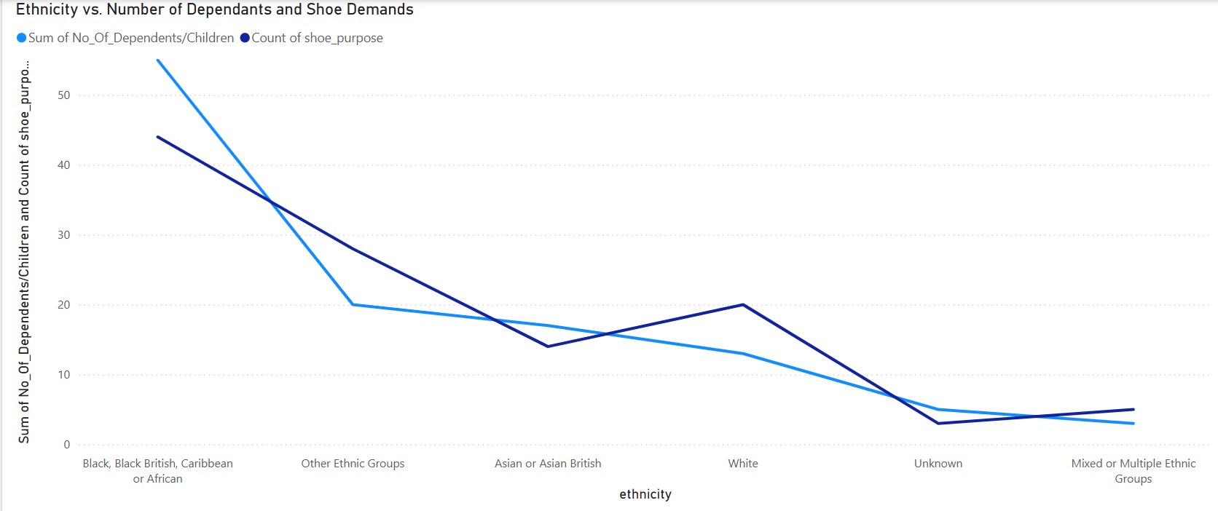

This line chart highlights how the number of dependants and shoe demands vary across ethnic groups, providing a clear view of trends and differences.

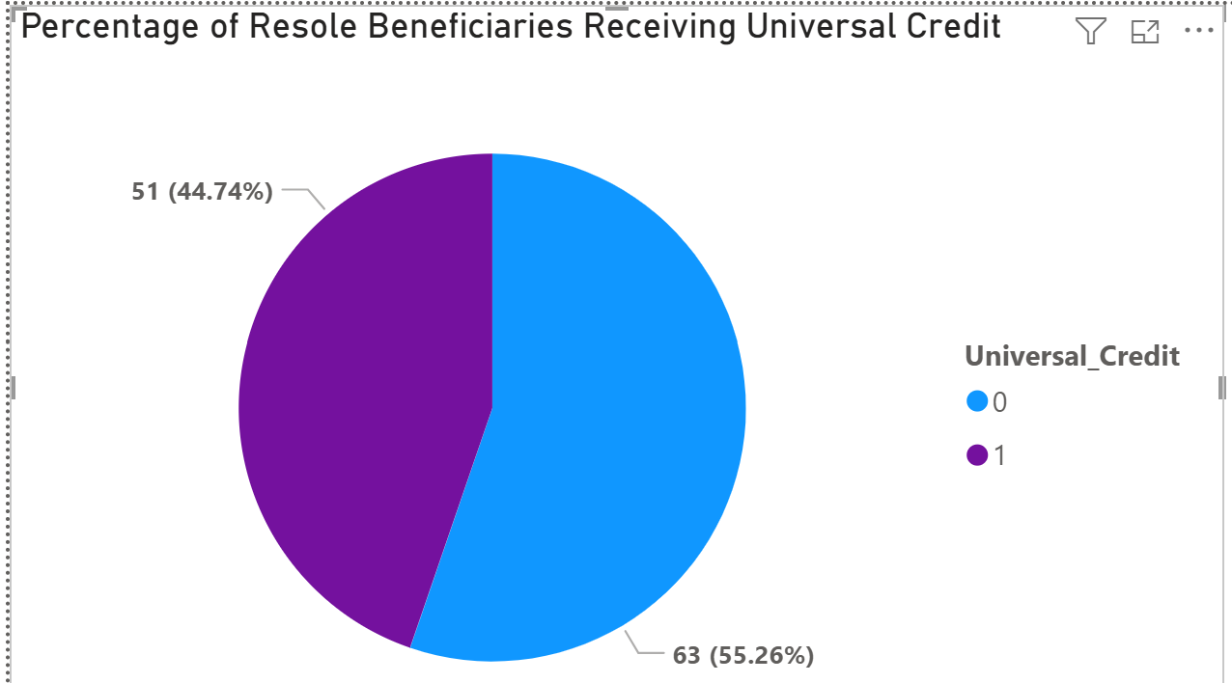

The Pie chart shows the number of people who receive Universal credit. The purpose of using that specific chart is so that it can help explore if financial support correlates with the number of dependants or shoe demands across different ethnic groups.

Also, 0 represents No, 1 represents Yes.

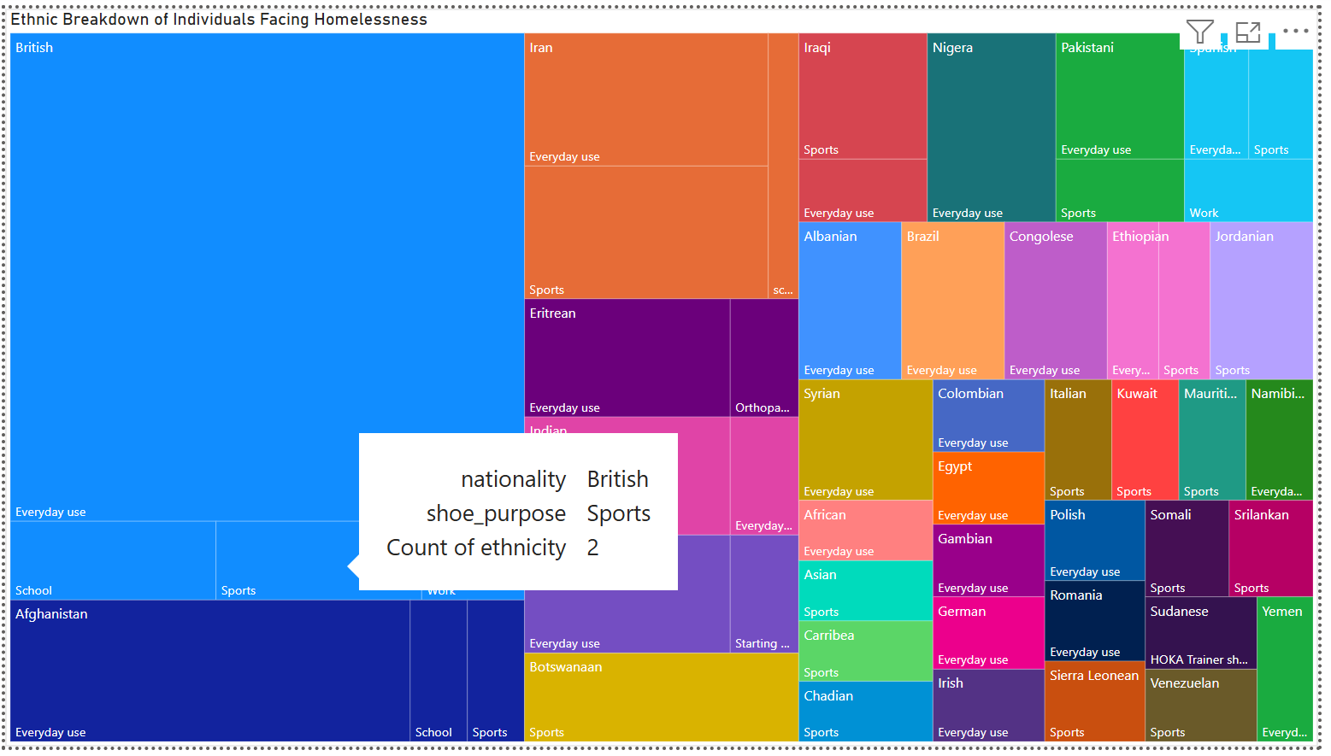

Moreover, this treemap helps visualise how shoe demands are distributed across different nationalities and ethnicities, highlighting the most significant contributors.

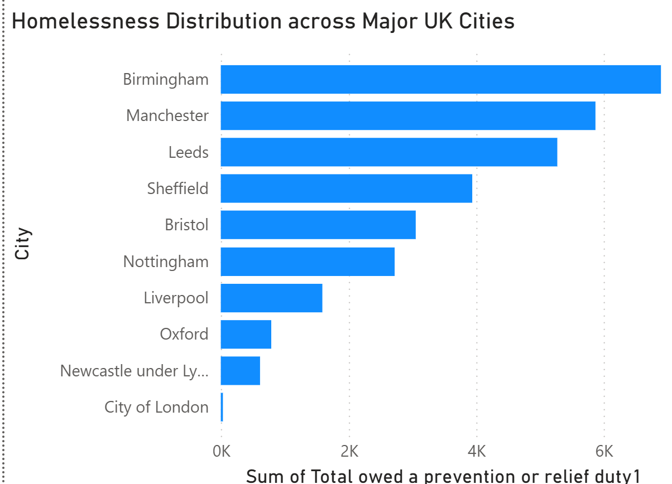

Furthermore, this bar chart displays the total homelessness across the top 10 cities in the UK. It highlights the cities with the highest levels of homelessness, making it easy to compare their impact.

***Github***: <https://github.com/Kelstudy/DLP_CW>

***Google Drive***: <https://drive.google.com/drive/folders/1ja07K8v2yAJucZzqUQkhVjx9hQy93ktF?usp=drive_link>

***References:*** (Everyone)

* Resole (n.d.) *Resole: Sustainable Shoe Repair & Upcycling Services*. Available at:<https://resole.org.uk/> (Accessed: 19 March 2025).
* WasteAway Group (2021) *How many shoes are in the landfill?* Available at:<https://wasteawaygroup.com/blog/How-Many-Shoe-Are-In-the-Landfill/> (Accessed: 19 March 2025).
* Nature (2023) *Nature: Latest trends in sustainability and the shoe industry*. Available at:<https://www.nature.com/articles/d42473-023-00276-5> (Accessed: 19 March 2025).
* Diagrams.net (n.d.) *Shoe sustainability diagram*. Available at: [https://app.diagrams.net/#G1B22uYfLsBRiwRPylMyMuWfS7yJtCQwpE#%7B%22pageId%22%3A%22G7Msy1v34nbQPyZi0fvw%22%7D](https://app.diagrams.net/#%7B%22pageId%22%3A%22G7Msy1v34nbQPyZi0fvw%22%7D) (Accessed: 19 March 2025).